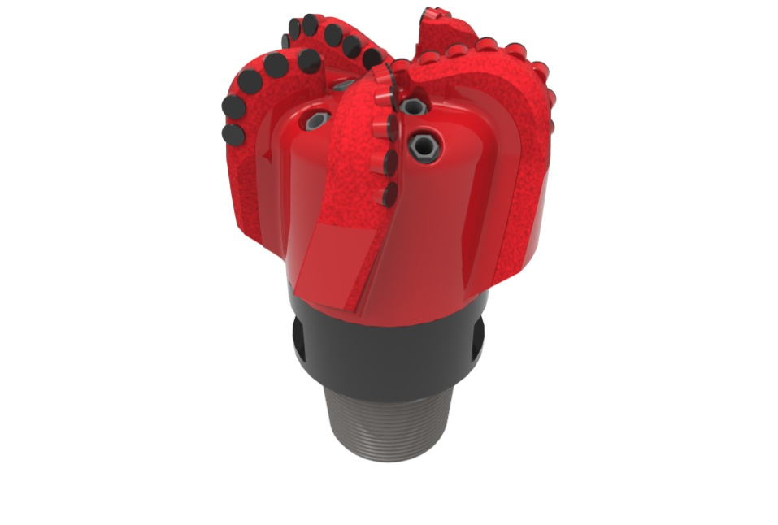
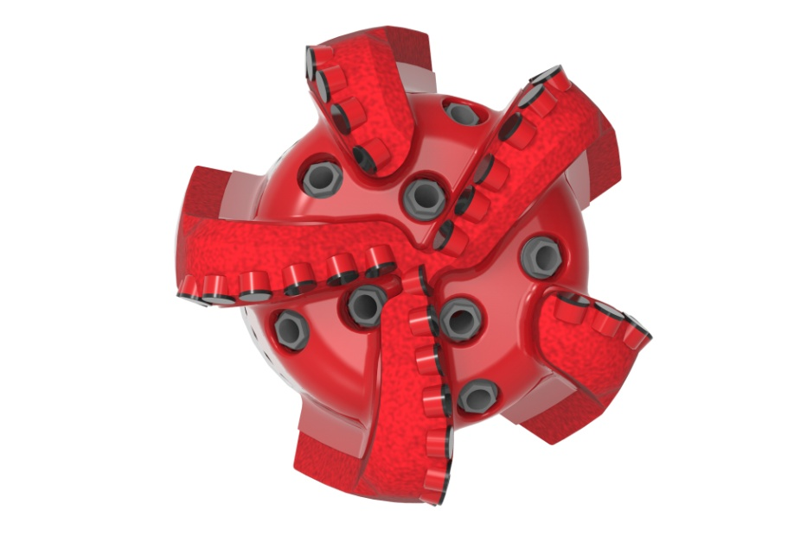

Drill Bit Specifications:
Cutter Size (Primary, Sec) | 3/4”
Cutter Count (Total, Gage) | 33,5
Blade Count | 5
Gage Length (Inches) | 3.00
Nozzle Count (Primary, Sec.) | 8
Nozzle Series (Primary, Sec.) | 60
JSA (Sq. Inches) | 30.08
Max. TFA (Sq. Inches) | 2.97
Operating Parameters:
Max. Weight on Bit (1,000 Lbs.) | 60
Make-up Torque (ft/lbs) | 40,563
Nominal Dimensions:
Overall Length (Inches) | *17.25
Make Up Length (Inches) | *12.38
Bit Breaker | SKB-21011
Connection | Ø6-5/8" API Reg.
Approx. Weight (Lbs.)  *Long tool joint available upon request (adds 6” to fishing neck, makeup and overall length, and 64 lbs to approximate weight). | *185

Standard Features:

- Large open face volume assists cuttings removal
- Eight nozzles optimize blade cleaning and cuttings removal
- Premium grade cutters maximize ROP and Life

519-SR8 Nomenclature Explained:

• | 5 | = | Number of blades
• | 19 | = | Primary Cutter Size (19mm)
• | SR+ | = | Single Row of Cutters
• | 8 | = | Number of Nozzles


